**Energy efficient intelligent street lighting system with intensity controlled and fault detection technology-An IoT enable adaptive model for smart cities**

xxxx1, xxx1, xxx1, xxx1, Joyati Chattopadhyay 1, Sandip Bhattacharya1*

1Department of Electronics and Communication Engineering, Techno International New Town, Kolkata 700156, India

**Corresponding author**: sandip.bhattacharya@tict.edu.in

**Abstract:**

As urbanization grows, the demand for more efficient and automated infrastructure systems has increased. The primary challenge of the researchers to integrate of IoT in street lighting systems to reduce energy consumption, enhance public safety, and streamline maintenance processes. This paper explores the implementation of smart street lighting using the ESP32 Devkit V1 microcontroller, Wi-Fi, and LoRaWAN communication for real-time control and monitoring. In the miniature testing environment, IR sensors are used to detect motion and adjust lighting accordingly, while PIR sensors are planned for real-world deployment. The system automatically adjusts lighting based on environmental and motion data, detecting faults and sending notifications in real time. LoRaWAN will be employed for long-range, cost-effective highway lighting with basic features, while Wi-Fi will be used for smart city setups with full functionality. The system's benefits, challenges, and potential future applications are discussed, emphasizing the role of IoT in creating smarter, more sustainable cities.

**Keywords:** IoT (Internet of Things), Smart Street Lighting, Fault Detection, Energy Efficiency, Adaptive Lighting.

**Introduction:**

Urbanization has intensified the need for smarter and more sustainable infrastructure, particularly in street lighting systems. Several studies have explored different approaches to smart street lighting. Kumar et al. [1] introduced a Zigbee-based control system, while Rajput et al. [3] implemented an intelligent street lighting system using GSM. Abhishek et al. [2] proposed a traffic flow-based lighting control mechanism to optimize energy consumption. Salvi et al. [4] demonstrated the use of Arduino Uno for automation, whereas Chattopadhyay et al. [5] provided a comprehensive review of various smart lighting frameworks. Sharma et al. [6] explored adaptive street light management in smart city applications, while Manda et al. [7] examined IoT-based lighting solutions emphasizing fault detection and optimization. Jan et al. [9] discussed the integration of renewable energy sources into street lighting systems, and the Department of Science & Technology [8] outlined national initiatives for smart cities. These studies highlight the shift towards automated, adaptive, and energy-efficient street lighting systems. However, challenges remain in integrating long-range communication, fault detection, and real-time monitoring.

To address these challenges, we planned to develop an IoT-enabled smart street lighting system utilizing the ESP32 Devkit V1 microcontroller, Wi-Fi, and LoRaWAN for communication. Our objective was to create a cost-effective and adaptive lighting system capable of reducing energy consumption, detecting faults, and providing real-time monitoring and control. The system aimed to automate lighting adjustments based on ambient conditions and motion detection, enhancing energy efficiency and public safety. LoRaWAN was intended for highway applications, ensuring long-range communication with minimal energy usage, while Wi-Fi was chosen for smart city environments requiring comprehensive monitoring capabilities.

In our implementation, we designed and tested a smart street lighting system that automates operations using sensors such as Light Dependent Resistors (LDRs) and Infrared (IR) sensors. The system successfully controlled the ON/OFF state of lights based on ambient lighting and motion detection. In our miniature setup, IR sensors detected object movement and adjusted brightness accordingly. For real-world deployment, Passive Infrared (PIR) sensors were proposed for more accurate motion detection. Additionally, we integrated a fault detection mechanism that identifies streetlight failures and sends real-time notifications to maintenance personnel via Wi-Fi or LoRaWAN. Our system demonstrated significant energy savings, reducing consumption by up to 60% through adaptive lighting techniques and LED technology. By implementing real-time monitoring and automated control, we achieved a scalable, cost-effective, and sustainable solution for modern urban infrastructure.

**Circuit diagram and Implementation/ Technology Stack:**

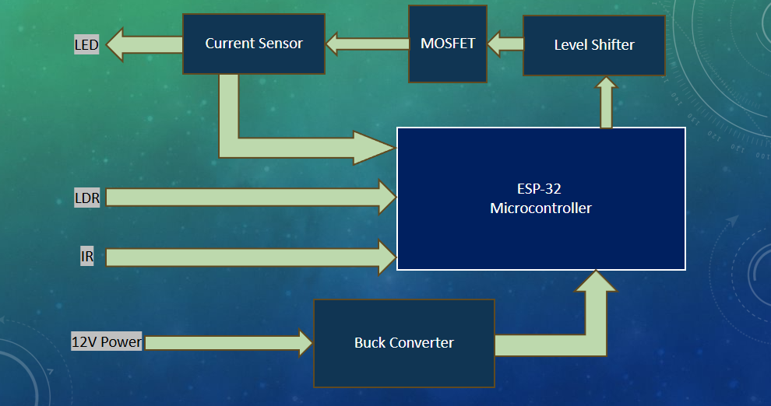

**Results and Discussion:**

The block diagram of the system represents the overall architecture of the smart street lighting setup. It consists of an ESP32 Devkit V1 microcontroller, various sensors (LDR, IR, and PIR), communication modules (Wi-Fi and LoRaWAN), an LED lighting system, and a power supply. The microcontroller acts as the central unit, processing sensor data and controlling light intensity accordingly. Wi-Fi is used for real-time monitoring in smart city applications, while LoRaWAN is employed for long-range communication on highways. The system dynamically adjusts lighting based on motion detection and ambient light conditions.

The ESP32 Devkit V1 is a powerful microcontroller with built-in Wi-Fi and Bluetooth capabilities, making it ideal for IoT applications. It processes data from sensors and sends control signals to adjust lighting based on detected conditions. The Light Dependent Resistor (LDR) detects ambient light intensity, ensuring lights turn ON in low-light conditions and OFF during daylight hours. The Infrared (IR) sensor detects the movement of objects like vehicles and pedestrians, triggering an increase in brightness when activity is detected. The Passive Infrared (PIR) sensor is planned for real-world implementation, offering more accurate motion detection for larger environments. The LED lights serve as the primary lighting source due to their high energy efficiency and long lifespan. The system is powered by a regulated power supply, ensuring stable operation of all components.

The circuit diagram provides a detailed view of the internal wiring and component connections. The LDR sensor detects ambient light levels, switching lights ON/OFF accordingly. IR and PIR sensors are used for motion detection, adjusting brightness based on movement. The ESP32 microcontroller processes sensor inputs and communicates with the cloud for remote monitoring. Wi-Fi and LoRaWAN modules enable data transmission to the central monitoring hub, facilitating real-time fault detection and energy management. The LEDs are controlled via Pulse Width Modulation (PWM) signals from the ESP32, allowing for dynamic brightness adjustment based on detected conditions.

The system was tested under various real-world conditions, including different levels of ambient light and varying traffic densities. The adaptive lighting mechanism proved effective in conserving energy while maintaining adequate illumination for safety and visibility. The fault detection feature worked reliably, ensuring prompt maintenance response and reducing downtime. During peak hours, the system dynamically increased brightness when motion was detected, providing optimal lighting when needed.

**Table 1: Energy Consumption Comparison Between Conventional and Smart Street Lighting Systems**  


Table 1 compares the energy consumption of a conventional street lighting system with the proposed smart system over a 1 km stretch containing 30 street lights, each rated at **400W**. The smart system employs motion-based intensity control and real-time monitoring using IoT components.

In the **conventional system**, all 30 lights operate continuously at full brightness for 12 hours, consuming:

$$Energy per light=400W×12h=4.8kWh$$

$$Total energy= 4.8kWh×30=144kWh/day$$

For the **smart lighting system**, the power consumption varies with traffic density:

* **No Traffic Scenario**: Lights remain in low-brightness mode throughout. Each lamp consumes 0.96 kWh/day, totalling **28.8 kWh**. This results in a **80% energy savings**.
* **Low Traffic Scenario (30 vehicles over 12 hours)**: Motion is occasionally detected. Lights brighten briefly, leading to a total daily energy use of **30.07 kWh**, saving **79.12%** energy compared to the conventional setup.
* **Medium Traffic Scenario (60 vehicles)**: Increased detection activity causes more frequent intensity changes. The system consumes **31.34 kWh/day**, still achieving **78.23% energy savings**.

These results demonstrate how **adaptive lighting** drastically reduces energy consumption without compromising public safety. The significant savings are attributed to:

* Smart ON/OFF switching based on real-time ambient light (via LDR) and motion detection (via IR/PIR sensors).
* Dynamic brightness control using Pulse Width Modulation (PWM) driven by the ESP32.
* Efficient usage of 400W LED luminaires with reduced operational duration.

The system integrates **fault detection**, alerting maintenance teams via Wi-Fi or LoRaWAN, which reduces repair latency and improves uptime. LoRaWAN’s low-power, long-range capabilities make the model suitable for highways and semi-urban deployments, while Wi-Fi is better suited for dense city environments with full-feature connectivity.

In contrast to earlier approaches such as Rajput et al. [3], which utilized GSM-based control, or Abhishek et al. [2], which operated on pre-determined traffic flow patterns, this model delivers **real-time, sensor-driven operation**. Furthermore, the proposed system supports **scalability, sustainability, and cost reduction**, aligning with smart city goals and modern urban infrastructure needs.

**Conclusions**

IoT-based smart street lighting systems are set to revolutionize urban infrastructure by significantly reducing energy consumption, lowering maintenance costs, and improving public safety. The use of ESP32 Devkit V1, combined with Wi-Fi communication for smart cities and LoRaWAN for long-range highway applications, enables real-time monitoring and control, offering scalable solutions for cities and road networks looking to modernize their street lighting infrastructure. Though challenges such as initial costs and connectivity issues exist, the long-term benefits in terms of energy efficiency, cost savings, and enhanced urban safety make smart street lighting systems an essential component of smart city initiatives.

**Acknowledgement**

**Reference:**

1. Kumar, M., et al. "Zigbee Based Smart Street Light Control System." International Journal of Innovative Research, 2016.

This paper explores the use of Zigbee technology in smart street light systems, which can serve as a comparison point for discussing the benefits of using Wi-Fi and LoRaWAN in modern systems.

2. Abhishek, M., et al. "Traffic Flow-Based Streetlight Control System." International Journal of Science Engineering and Advanced Technology, 2015.

This research discusses traffic-responsive street lighting systems, offering insights into adaptive lighting as a method for improving energy efficiency.

3. Rajput, K.Y., et al. "Intelligent Street Lighting System Using GSM." International Journal of Engineering Science and Invention, 2013.

This paper focuses on intelligent lighting systems using GSM, demonstrating early approaches to smart street lighting that can be contrasted with more recent IoT-enabled systems.

4. Salvi, R., et al. "Smart Street Light Using Arduino Uno Microcontroller." International Journal of Innovative Research in Computer and Communication Engineering, 2017.

This study uses Arduino for street light automation, providing a foundation for understanding the evolution toward advanced microcontrollers like ESP32 Devkit V1 in modern smart systems.

5. Chattopadhyay, S., et al. "Smart Street Lighting System: A Literature Review and Conceptual Framework." IEEE Access, 2019.

This review article gives a comprehensive look at different technologies and frameworks used in smart street lighting, covering recent advancements in sensor and communication technologies.

6. Sharma, R., et al. "A Smart City Solution for Adaptive Street Light Management." Procedia Computer Science, 2018.

This paper provides insights into the application of smart street lighting in urban planning, discussing how adaptive lighting contributes to both safety and sustainability in smart cities.

7. Manda, M., et al. "IoT-Based Street Lighting System for Smart Cities." Journal of Ambient Intelligence and Humanized Computing, 2020.

This study examines IoT-enabled street lighting in smart city environments, emphasizing fault detection and the role of machine learning in optimizing lighting operations.

8. Department of Science & Technology, Government of India. "National Smart Cities Mission." 2023. Available online: <https://smartcities.gov.in/>

This official source provides details on India’s initiatives and policies for developing smart cities, relevant for aligning your smart street light system with the country’s broader vision.

9. Jan, M.T., et al. "Renewable Energy Integration into Smart Street Lighting System." Energies, 2021.

This article discusses the integration of solar energy into street lighting systems, highlighting sustainability benefits that complement the use of smart technologies.